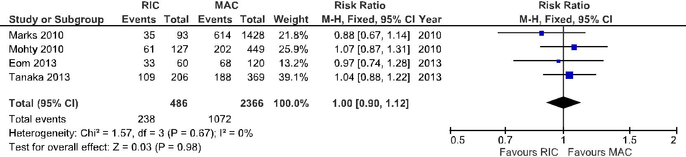

**Fig 1. Forest plot of comparison: 1.Overall Survival(OS), outcome: 1. Overall Survival (OS).**

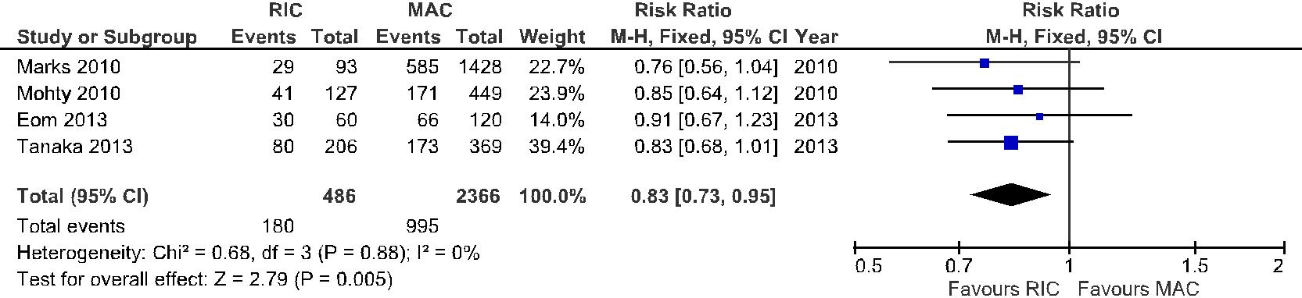

**Fig 2. Forest plot of comparison: 2.Disease Free Survival (DFS), outcome: 2. Disease Free Survival**

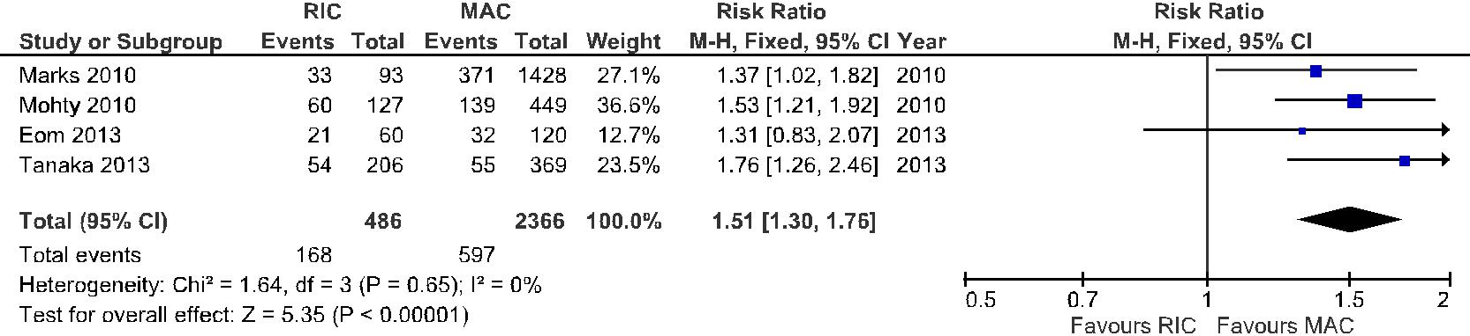

**Fig 3. Forest plot of comparison: 3.Relapse Incidence, outcome: 3. Relapse Incidence.**

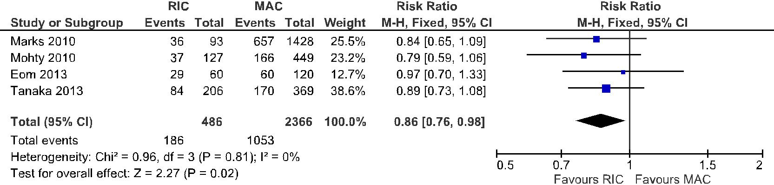

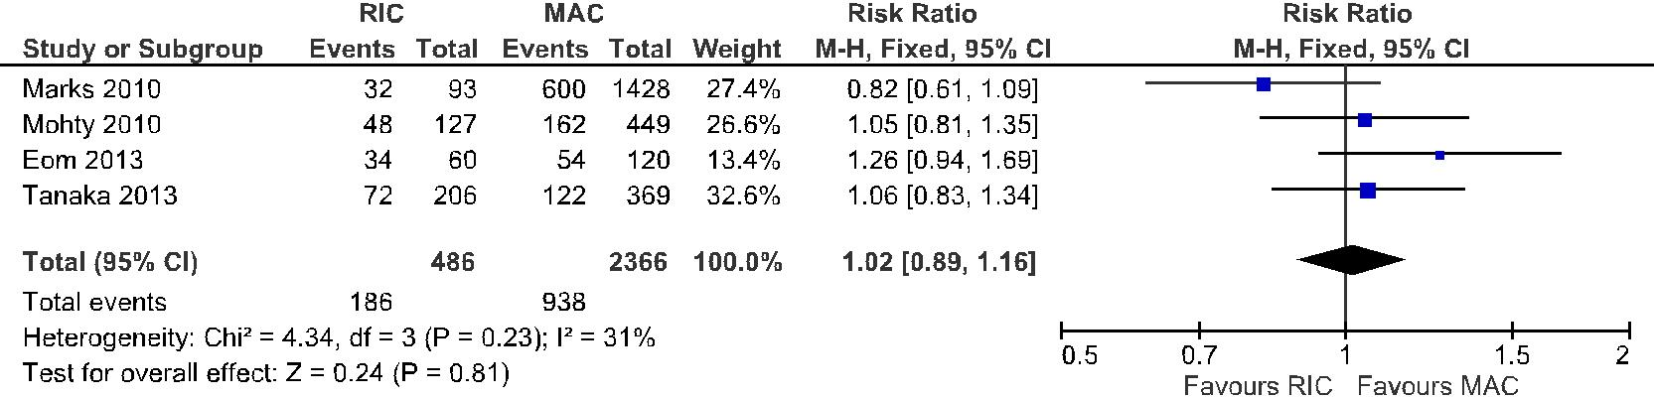**Fig 4. Forest plot of comparison: 4.Acute GVHD, outcome: 4. Acute GVHD.**

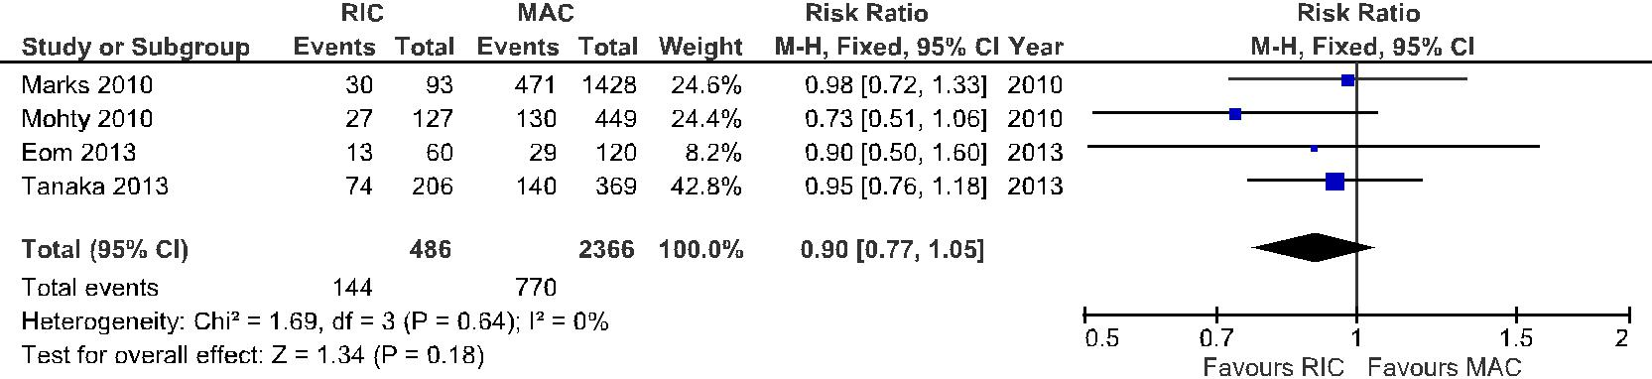**Fig 5. Forest plot of comparison: 5.Chronic GVHD, outcome: 5. Chronic GVHD.**

**Fig 6. Forest plot of comparison: 6.Non-Relapse Related Mortality, outcome: 6.Non-Relapse Related Mortality.**